Statement
for
Lockheed Martin Corporation
Testimony by Larry McQuien
Vice President Business Ventures
Lockheed Martin Aeronautics Company
Before The
United States Senate
Committee on
Homeland Security and Governmental Affairs
September 27, 2007 Hearing on
Cost Effective Airlift in the 21st Century

Executive Summary
Modernization of the C-5 Galaxy is a fiscally sound means of addressing United States strategic airlift requirements. The acquisition strategy for the C-5 Reliability Enhancement and Re-Engining Program (RERP) is to improve reliability, maintainability and availability while reducing total ownership costs. Current developmental testing indicates these goals are attainable. Lockheed Martin Corporation is committed in supporting its United States Air Force customer’s decisions on modernization of its strategic airlift fleet. Lockheed Martin provided to the Air Force a firm fixed price commitment for the portion of the RERP to be performed by Lockheed Martin to demonstrate our confidence in the estimated cost for the program of record.

The Air Force will realize 4:1 savings in C-5 Operations and Support costs savings through 2040 – based on Lockheed Martin’s estimate for the program, for every $1 invested in C-5 modernization the Air Force will save $4.

Operations and Support cost savings of $50B (then year dollars) ($20B base year 2000) through 2040 are achievable from the C-5 RERP modernization. Additional savings are also realizable through reduced fuel costs given the efficiency of the new General Electric CF6-80C2 propulsion system.

Mission Capability rate projections for the C-5M based on the improved reliability and maintainability of the modernized aircraft indicate that a 30% improvement is realizable in aircraft availability.

The C-5 has more than half of its useful structural life remaining – another 30 years -- and the RERP program is prudent to realize the investment in these aircraft rather than parking them in the Arizona desert.

Lockheed Martin submitted a firm fixed price proposal to the Air Force for RERP modernization of the C-5 fleet that specifically demonstrated Lockheed Martin could perform its portion of the RERP program for an average cost of $83M per aircraft. After estimating the other costs to be incurred on the program by the Air Force, our proposal indicates the average cost for modernization is between $108 and $118M per aircraft.

Lockheed Martin’s proposal can be executed within the current Future Years Defense Plan (FYDP) through 2013. Beyond the FYDP, execution of Lockheed Martin’s proposal would require new appropriations of at least $1.4B beyond the $9.8B currently budgeted for the total program. The total additional appropriations required would be dependent on changes in the other costs to be incurred by the Air Force over the original budget.

The effectiveness of mobility platforms can be measured against many different characteristics including such operational capabilities as the amount of material they move and the battlefield effects they create for the warfighter. United States fiscal constraints certainly shape airlift force structure. It is Lockheed Martin’s opinion that C-5 modernization represents an excellent balance of operational capability framed within the reality today’s budget constrained environment. The C-5 fleet is structurally sound, it is operationally relevant, and represents a good fiscal opportunity for the taxpayer.

The 2005 Mobility Capabilities Study (MCS) and 2006 Quadrennial Defense Review (QDR) affirmed modernization of the entire C-5 fleet as part of the Nation’s strategic airlift solution. These studies identified a strategic airlift requirement to move 54.5 million ton miles of cargo daily and concluded that 112 C-5Ms and 180 C-17s would meet that requirement at an acceptable risk when combined with the Civil Reserve Air Fleet (CRAF). Congressional legislation raised the number of authorized aircraft from 292 to 299. This conclusion recognized the fact that the C5M (the designation for a modernized C-5 A/B/C) carried about twice the cargo as a C-17 and that the CRAF was not suitable for moving outsized and oversized cargo that could be carried by the C-5 and C-17. Increases in United States Army and United States Marine Corps troop strengths since those studies may place more requirements on strategic airlift requiring more aircraft to continue to meet the requirements at an acceptable risk level.
C-5 Modernization
C-5 modernization is a two phased program including the Avionics Modernization Program (AMP) and the Reliability Enhancement and Re-Engining Program (RERP). .

Phase 1 AMP delivers a modern digital glass cockpit including communication, navigation, surveillance/air traffic management, and navigation/safety capability as directed by the DoD. AMP development is complete, operational testing and evaluation is complete, the Air Force has declared initial operational capability and Lockheed Martin has produced 28 upgraded aircraft.

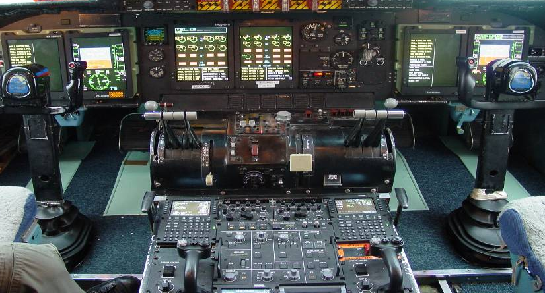

Phase 2 RERP is a comprehensive modernization effort (70+ initiatives) improving aircraft reliability, maintainability, and availability. RERP enables C-5s to achieve wartime mission requirements by increasing fleet availability, mission capability, departure reliability, while reducing total ownership costs. The AF’s approved acquisition strategy supports AMP and RERP for all 111 aircraft. AMP + RERP = C-5M (modernized C-5). RERP is progressing very well with three C-5M Super Galaxies (2 former C-5Bs, 1 former C-5A) active in developmental testing. As of 27 September, approximately 60% of developmental testing is complete with a plan to be complete by August 2008.

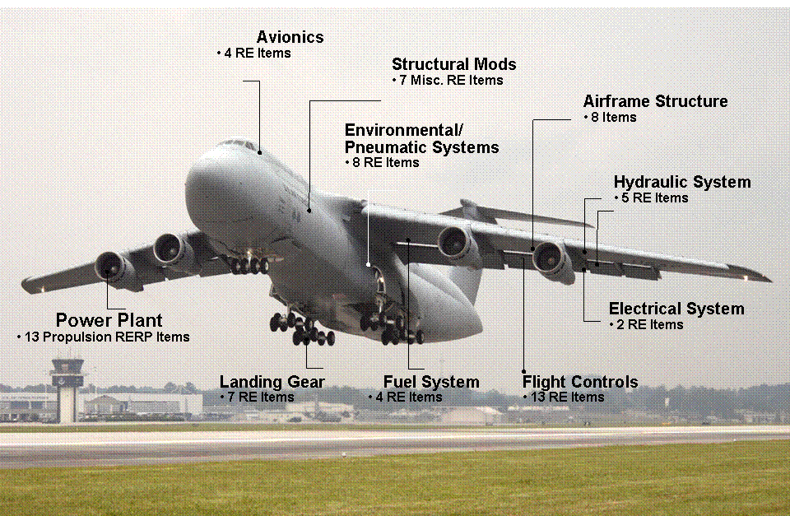

The centerpiece of the modernization program is the reliable, commercial General Electric (GE) CF6-80C2 (CF6) turbofan engine with increased takeoff thrust, stage-3 noise compliance and Federal Aviation Regulation pollution compliance. More importantly, this propulsion system has demonstrated outstanding reliability having accumulated more than 300 million flight hours in both commercial and military applications. The contribution of the various modernization improvements to the overall availability of the aircraft is set forth in the following figure along with the projected improvement in mission capability rate. Our analysis indicates that an improvement in mission capability rate for the C-5 of more than 30% over the 1998 baseline (or 26% over the 2005 data) is achievable with the RERP modification.

Cost Effectiveness
The RERP program achieves substantial tax dollar savings. Operations and Support (O&S) savings through 2040 are projected at $49.8B in TY dollars ($20.4B in base year 2000 dollars). Fuel savings of another $2B, or more, are also reasonably achievable given the fuel efficiency of the GE CF-6 propulsion system. Reduced total ownership costs of $37B to $38 in TY dollars are projected based on Lockheed Martin’s proposal assuming the “other costs” to be incurred by the Air Force are within 30 – 45% of Lockheed Martin’s proposed costs. Recent discussions with the Air Force have suggested that their estimate of the “other costs” is 45% of our cost. These data show that $4 in O&S cost savings are achievable for every $1 invested based on Lockheed Martin’s proposal assuming a range of 30 – 45% for the Air Force “other costs.”
Our Proposal
In 2006, it became apparent that the cost to perform the RERP would exceed what the Air Force and Lockheed Martin had envisioned in 2001 when the program was authorized. Lockheed Martin provided the Air Force a firm fixed price (FFP) proposal on May 17, 2007 to modernize the remaining 108 C-5 aircraft. This proposal was submitted in response to a request for proposal (RFP) from the Air Force that requested firm pricing for lots 1 – 3 at aircraft lot quantities of 1, 3 5–8, and a not-to-exceed (NTE) price for the remaining C-5 B/C aircraft at to-be-determined aircraft lot quantities. Lockheed Martin restated its offer on August 28, 2007 changing the FFP option pricing for Lots 4 and beyond to firm NTE lot option commitments. We made this change given concerns voiced by the Air Force on the lack of supplier proposal substantiation for those lots. Lockheed Martin based its proposal for these lots on a firm proposal for the propulsion system and upon estimates for the remaining material costs based on the supplier proposals for Lots 1 – 3. The propulsion system represents about 50% of the material cost of the program. Lockheed Martin made the decision to commit to firm fixed prices to the Air Force based on its confidence in these data. As restated, Lockheed Martin committed to the Air Force to perform its portion of the RERP program, as proposed, for a price, no greater than $8.956B. The restated NTE prices for Lots 4 and beyond gave the Air Force the opportunity to negotiate lower values in the future while capping their exposure at the NTE amount. Lockheed Martin’s offer included an economic price adjustment for any unusual inflation above that assumed in the proposal (the proposal was based on published inflation indices through 2020) and excluded unforeseeable impacts due to diminishing manufacturing sources beyond Lot 3 should manufacturers experience technical obsolescence concerns or change the focus of their business.

Lockheed Martin structured the proposal to ensure the Air Force had an accurate assessment of the cost for the RERP modernization program in connection with the Service’s on-going discussions on the composition of the strategic airlift force structure. Lockheed Martins average per ship cost is about $83M, as depicted.
The bar chart depicts the per ship cost for Lockheed Martin’s content while the table below sets out the proposed lot pricing. Lot 8 is split into two components in the bar chart merely to highlight the junction in the production program where the C-5As begin modernization. The average per ship total program price based on our proposal ranges from $107.8M to $119M depending on changes to the original budget for the “other costs”(such as training, spares, support equipment, over and above maintenance, program management) to be incurred by the Air Force. Lockheed Martin was requested to provide an estimate for a defined set of spares and support equipment in Lots 1 through 3 as set out in the above table, but Lockheed Martin was not asked to provide its estimate for these costs beyond Lot 3.

Lockheed Martin’s offer does not require the Air Force to commit to modifying all C-5s, but gives them solid data to analyze various fleet mix options. The proposal was structured as an initial lot and 11 lot options based on specified lot quantities. The production build rate is shown in the following figure. Funding requirements based upon this rate when compared with the FYDP indicate sufficient funds exist across the FYDP to execute the program but the funding is not phased to coincide with Lockheed Martin production requirements. For the purpose of the following figure, Lockheed Martin assumed the Air Force “other costs” could be estimated as being 30% of Lockheed Martin’s costs. We have recently learned that the Air Force estimate for these “other costs” is about 45% of our costs. It still appears that there are sufficient funds through the FYDP to execute the proposal but the phasing of those funds needs to be adjusted to coincide with the funding requirements. Additional appropriations of at least $1.4B are required post FYDP to execute our offer as well as a rephasing of the excess funds appropriated through the FYDP (total additional appropriations would be dependent upon changes to the other costs to be incurred by the Air Force over the original program budget).

Airframe Structural Viability
Full scale structural tests and analysis have resulted in establishing a structural life of 45,000 hours for the C-5 airframe. These tests and analysis took advantage of the fact that the wing for the C-5B was redesigned prior to its production to address some structural life concerns revealed during the fatigue testing of the original C-5A. Lockheed Martin retrofitted all C-5As with the new wing in the late 80s. The 45,000 structural life greatly exceeds the Air Force planned usage between now and 2040, i.e. annual flying rates of 300 and 600 hours, respectively. The average flight hour usage for both the A and B fleets (the 2 C-5C’s are A model aircraft modified to transport outsized Space Cargo) has yet to reach the halfway mark as shown in the following figure. (The chart also depicts the fact that the aircraft are all consistently operating about the same from a flight hour perspective which is some evidence that there are no broken or worn-out aircraft in the fleet.)

The 2004 Air Force Fleet Viability Board examined the health of the C-5A fleet and found it “assessed to be viable” with “no major structural life issues”. The report also noted previous studies conducted by the Aeronautical Systems Center (Dr. Lincoln report) which showed the projected economical use of the C-5 to 2040 was quite feasible. In 2005 – 2006, the Air Force completed a 4-phased destructive inspection of C-5A 69-0004 to assess overall health of the early C-5As. This inspection revealed no significant structural issues that would undermine long-term C-5A fleet service. The C-5A was first Air Force aircraft built to MIL-STD-1568 corrosion prevention requirements, and there are no widespread corrosion issues in the fleet.
Test and analysis have shown that the structural life of the C-5A aircraft greatly exceeds the 2040 timeframe.

There are, however, some structural maintenance issues that may need to be addressed. These arise mainly from the use of –T6 temper aluminum alloys that were developed in the 1960’s and later learned to be susceptible to stress corrosion cracking. The issue is well understood and these repairs are addressed today as maintenance actions on “as-needed” basis. An estimate of the cost for these repairs is summarized in the adjoining table, but not all aircraft need all of the repairs. Lockheed Martin has been working with WR-ALC on the potential for packaging the maintenance activities to minimize cost and aircraft down-time.

Lockheed Martin conducted a study in early 2007 to assess the impacts of sustained high operations tempo on the C-5 fleet over extended time. This study was undertaken given the tempo of the aircraft supporting Operational Iraqi Freedom and Operation Enduring Freedom. The C-5 A/Bs have been operated the last 3 years about 50% higher than the 300/600 hour planning numbers relied upon in current studies. The goal of the study was to define what effects these ops tempos would have on the 45,000 hour structural life associated with the RERP configuration. The study concluded that the modernized C-5M safety limits were not exceeded until well after 2040 even at sustained higher ops tempos.
Summary
Modernized C-5Ms (regardless of whether they were originally C-5As/Bs) can effectively serve the United States strategic airlift requirements well beyond 2040. Modernizing the C-5 fleet remains the most fiscally sound solution for meeting the Nation’s strategic airlift requirements by returning to the Air Force $4 for every $1 invested in the production program. Air Force acceptance of Lockheed Martin’s offer would require additional Congressional appropriations in the 2014 – 2020 timeframe in an amount of at least $1.4B and as much as $3.1B depending on the amount of the “other costs” to be incurred by the Air Force. The C-5 airframe has more than half of its structural life remaining and it would be prudent to modernize these aircraft to protect the investment made by the government and the taxpayers and realize the C-5’s full potential rather than parking them in the Arizona desert. The 2005 Mobility Capabilities Study (MCS) and 2006 Quadrennial Defense Review (QDR) affirmed modernization of the entire C-5 fleet as part of the Nation’s strategic airlift solution. The C-5, unheralded, flew 25% of the Operation Iraqi Freedom airlift missions deploying for the war, yet delivered 50% of the cargo. The C-5M can continue providing exceptional capability through 2040. The increased funding required to complete the program would be a good investment in a superb aircraft.

Conclusion
Mr. Chairman, Lockheed Martin fully understands the challenges facing the Air Force and we intend to support the decisions of our customer. We appreciate the opportunity for an open and constructive dialogue regarding the merits of our proposal. The Air Force Program of Record supports C-5 fleet modernization and Lockheed Martin is committed to meeting its customer’s requirement.

